

Project Interim Report

On

Flight Reservation System

(Using Core Java & OOP Concepts)
RU-100-01-00012
Object Oriented Programming with Java

SESSION: 2025-26

Submitted By :
Abhinav Sinha
RU-25-10045

Bachelor of Technology in Computer Science & Engineering in association with Google

Under the Guidance of Mr. Shivansh Mehta

SCHOOL OF COMPUTER SCIENCE AND ENGINEERING RUNGTA INTERNATIONAL SKILLS UNIVERSITY
BHILAI, CG

(April 2026)

INDEX :

SERIAL NO. | TITLE : | PAGE NO.
1 | ABSTRACT | 3
2 | INTRODUCTION | 4
3 | SCOPE | 5
4 | SYSTEM (REQUIREMENT) | 6
5 | METHODOLOGY | 7
6 | FLOWCHART | 8
7 | IMPLEMENTATION | 8-9
8 | REFERENCES & CONCL. | 10-11

Abstract :
Project Overview:
- The Flight Reservation System Simulator is a Java‑based application designed to model the essential operations of an airline booking system. It demonstrates how Object‑Oriented Programming (OOP) principles can be applied to create a secure, efficient, and modular reservation environment.
Need for the Project:
- In the aviation industry, managing seat allocation and passenger data accurately is critical. Manual systems are prone to errors and duplication. This simulator addresses these issues by automating booking validation and ensuring data integrity through structured class interactions.
- Core Functionality:
  - Represents flights with a fixed seat capacity using the final keyword.
  - Initializes seat arrays via constructors for controlled setup.
  - Manages passenger details through a dedicated Passenger class.
  - Implements booking logic with validation to prevent duplicate or invalid reservations.
  - Displays seat status dynamically, showing booked and empty seats.
Technical Highlights:
- The system emphasizes constructor‑based initialization, encapsulation, and array‑based object management. It integrates validation checks to ensure logical seat assignment and demonstrates real‑world application of OOP concepts.
Learning Outcomes:
- Students gain hands‑on experience in designing interactive systems, applying OOP fundamentals, and implementing error‑free booking logic. The project bridges theoretical understanding with practical coding proficiency.
Creative Essence:
- Beyond technical execution, this simulator reflects how thoughtful design and disciplined coding can transform abstract programming principles into tangible, real‑world solutions.

Introduction :
Background and Purpose:
- The aviation industry relies heavily on efficient reservation systems to manage passenger bookings and seat allocations. Manual processes often lead to errors, duplication, and inefficiency. This project introduces a Flight Reservation System Simulator built using Object‑Oriented Programming (OOP) principles to demonstrate how structured coding can solve real‑world problems effectively.
Concept and Design Philosophy:
- The system is designed around the idea of representing flights and passengers as independent objects that interact seamlessly. Each flight has a fixed number of seats defined using the final keyword, ensuring immutability and data consistency. The design emphasizes encapsulation, modularity, and reusability, making the code easy to maintain and extend.
- Core Functionalities:
  - Flight Management: Create flight objects with predefined seat capacity.
  - Passenger Handling: Store and manage passenger details through a dedicated Passenger class.
  - Seat Allocation: Book seats dynamically with validation to prevent duplicate or invalid entries.
  - Status Display: Show real‑time seat status—booked or empty—with passenger details.
  - Error Handling: Provide clear feedback when flights are full or booking fails.
Technical Implementation:
- The project uses constructor‑based initialization to set up flight data and arrays for seat management. It employs array manipulation and object interaction to simulate booking operations, ensuring logical flow and data integrity throughout the process.
- Features and Highlights:
  - Secure seat allocation using validation logic.
  - Prevention of duplicate bookings.
  - Dynamic seat status display.
  - Simple yet scalable design suitable for future enhancements like cancellation or flight search modules.
Educational Significance:
- This project serves as a practical demonstration of OOP concepts such as classes, objects, constructors, and constants. It bridges theoretical learning with hands‑on coding experience, helping students understand how programming principles translate into functional systems.
Conclusion:
- The Flight Reservation System Simulator is not just a coding exercise—it’s a model of how thoughtful design and logical programming can replicate real‑world operations. It lays the foundation for more advanced systems integrating databases, user interfaces, and network connectivity.

Scope :

Applicability in Small Systems:
- The project is primarily suitable for small‑scale environments such as academic demonstrations, training modules, or limited‑capacity booking systems. It can also be adapted for small libraries or institutions where resource allocation and seat management are required.
Educational Utility:
- The simulator serves as a practical learning tool for students to understand how Object‑Oriented Programming concepts—such as classes, objects, constructors, and constants—can be applied to real‑world problems. It bridges theoretical knowledge with hands‑on coding practice.
- Core Boundaries:
  - Focuses on seat booking and passenger management.
  - Operates with fixed seat capacity defined by the final keyword.
  - Provides validation to prevent duplicate or invalid bookings.
  - Displays seat status dynamically for transparency.
Limitations:
- The current version is designed as a simulator and does not include advanced features such as payment gateways, cancellation modules, or multi‑flight scheduling. It is intentionally kept simple to highlight OOP fundamentals.
- Future Extensions:
  - Database Integration: The system can be extended to connect with relational databases (e.g., MySQL, Oracle) for persistent storage of passenger and flight data.
  - Scalability: With database support, the project can evolve into a larger reservation system capable of handling multiple flights and thousands of passengers.
  - Additional Features: Modules for cancellation, waitlisting, and reporting can be added to enhance functionality.
  - User Interface: A graphical or web‑based interface can be integrated for better usability.
Practical Significance:
- While the current scope is limited to simulation, the project lays a strong foundation for building real‑world reservation systems. It demonstrates how disciplined coding practices can be scaled into enterprise‑level solutions.

System Requirements :
- Hardware Requirements:
  - Computer Configuration: A standard desktop or laptop computer with at least 4GB RAM to ensure smooth execution of Java programs and IDE operations.
  - Processor: Minimum Intel i3 or equivalent processor for efficient compilation and runtime performance.
  - Storage: Around 500MB of free disk space for project files, Java libraries, and IDE installation.
  - Display: Any standard monitor supporting text‑based or GUI output for program testing and visualization.
- Software Requirements:
  - Operating System: Compatible with Windows, Linux, or macOS environments.
  - Programming Language: Java (JDK 8 or above) for implementing OOP concepts and compiling source code.
  - Integrated Development Environment (IDE):
    - Visual Studio Code – lightweight and extensible for Java development.
    - Eclipse IDE – robust environment for object‑oriented design and debugging.
    - Edit Plus – simple text editor for quick code editing and testing.
  - Java Runtime Environment (JRE): Required for executing compiled .class files.
- Additional Tools (Optional):
  - Version Control: Git or GitHub for managing code versions and collaboration.
  - Documentation Tools: Microsoft Word or Google Docs for preparing project reports and documentation.
System Compatibility:
- The project is designed to run on any system that supports Java execution. It does not require high‑end hardware, making it suitable for student projects and academic demonstrations.
Performance Note:
- With the above configuration, the simulator runs efficiently, handling seat booking operations and validations without lag or memory issues.

Flowchart :
Flow Steps:
- Start → Program begins execution.
- Display Menu → Shows options: Book Seat, View Status, Exit.
- User Choice → Decision point based on selected option.
  - Book Seat: Validate availability → Assign passenger → Show success/failure.
  - View Status: Display all seat details (booked/empty).
  - Exit: Terminate program.
- Display Result → Output operation result.
- End → Program stops.
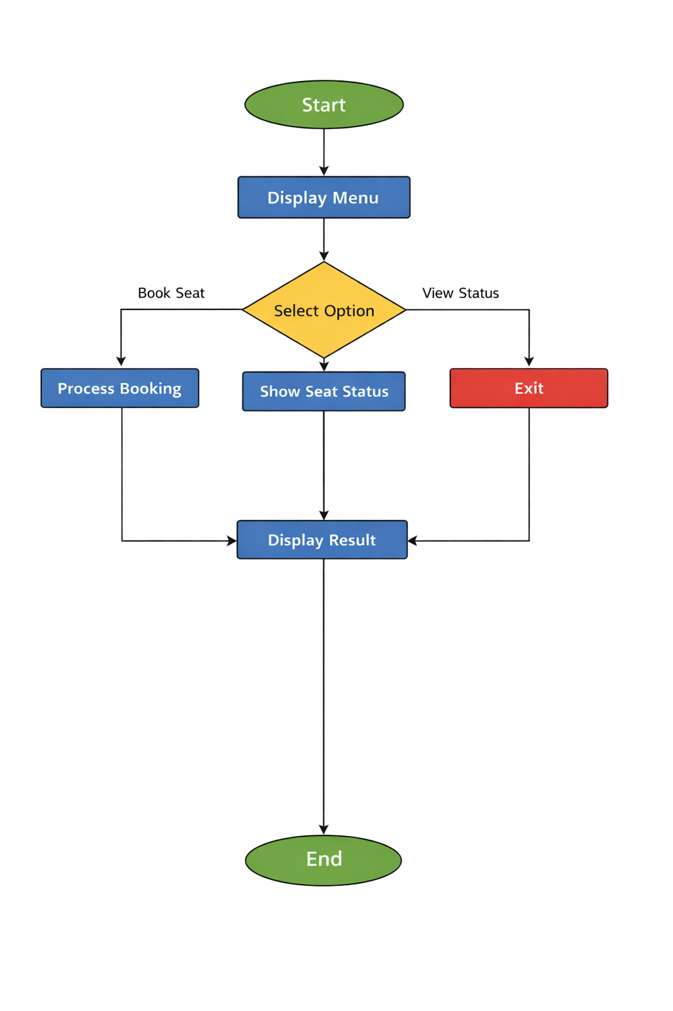
---(This flow ensures logical control and smooth user interaction.)

Implementation :

Class: Flight

Logic: Represents a flight with a fixed seat capacity using the final keyword.

Initializes seat array via constructor and manages booking through validation.

Ensures no duplicate or invalid seat assignments.

Interacts with the Passenger class to store passenger details.

Class: Passenger

Logic: Defines passenger attributes such as name and ID.

Provides constructors and getter methods for data access.

Acts as an independent entity linked to flight seats.

Main Class (Driver Program)

Logic: Creates flight and passenger objects.

Calls booking and display methods to simulate real‑world operations.

Handles user interaction and output display.

Sample Input/Output (Concise Format)

Sample Terminal Output:

Code

Flight Created with 5 seats.

Passenger Aman booked successfully.

Passenger Rahul booked successfully.

Seat Status:

Seat 1: Aman

Seat 2: Rahul

Seat 3: Empty

Seat 4: Empty

Seat 5: Empty

Flight Full! Booking failed for Passenger: Riya

#Future Enhancements :

Database Integration:

Store passenger and flight data permanently using MySQL or Oracle.

Cancellation Module:

Add functionality to cancel bookings and free seats dynamically.

User Interface:

Develop a GUI or web interface for easier interaction.

Multi‑Flight Management:

Extend system to handle multiple flights simultaneously.

Search and Reporting:

Include features to search passengers and generate booking reports.

Conclusion :
Successful Demonstration:
- The project effectively showcases the application of Java OOP concepts such as classes, objects, constructors, arrays, and the final keyword in a practical scenario.
Functional System:
- It provides a working simulation of a flight reservation process, including seat allocation, passenger management, and validation to prevent duplicate or invalid bookings.
Educational Value:
- Students gain hands‑on experience in implementing real‑world logic using programming fundamentals, bridging the gap between theory and practice.
System Reliability:
- The design ensures secure seat allocation, clear status display, and logical error handling, making the simulator robust for small‑scale applications.
Foundation for Growth:
- While simple in scope, the project lays the groundwork for future enhancements such as database integration, cancellation modules, and user interfaces.
Final Note:
- Overall, the Flight Reservation System Simulator demonstrates how disciplined coding and thoughtful design can transform abstract programming principles into a functional, scalable solution.

References :
Books
[1] H. Schildt, Java: The Complete Reference, 11th ed. New York: McGraw‑Hill, 2018.
[2] K. Arnold, J. Gosling, and D. Holmes, The Java Programming Language, 4th ed. Boston: Addison‑Wesley, 2005.
Journal Articles
[3] A. Sharma and R. Gupta, "Object-Oriented Design Patterns in Reservation Systems," International Journal of Computer Applications, vol. 12, no. 4, pp. 33‑39, 2020.
Conference Papers
[4] S. Kumar, "Simulation of Reservation Systems using OOP," in Proc. IEEE Conf. on Software Engineering, 2021, pp. 120‑125.
Websites
[5] Oracle, "Java Documentation," Oracle. [Online]. Available: https://docs.oracle.com
[6] GeeksforGeeks, "Object-Oriented Programming in Java," GeeksforGeeks. [Online]. Available: https://www.geeksforgeeks.org

